Norwin Middle School Cross Country- 2022 Summer Training and Information: “Pride, Tradition, and Family”

Middle School Head Coach: Varsity Head Coach:
Neal Nanassy (nnanassy@norwinsd.org) Brian Fleckenstein (bfleckenstein@norwinsd.org)

What is Cross Country:
- A Norwin School District sponsored team for students in grades 7 and 8 that enjoy running
- We compete against other MS teams at after-school meets, along with 2 – 4 Saturday invitationals
- Our races are usually around 1.75 miles (3K) and are typically run through fields and woods
- We have optional summer conditioning workouts and practice daily after school until 4:30 / 4:45 PM
- Our practices are held on campus (Hillcrest lawns) or at Oak Hollow Park in North Huntingdon (Monday-Friday)
- On “Oak Hollow practice days”, students are bused to Oak Hollow Park; parent pick up AT THE PARK is at 4:30 / 4:45 PM.

What you need to do to join the team:
(1) Sign up for Roster (all athletes)
(2) Sign up for Remind (if NOT getting messages or new to XC). Remind is a convenient way to receive pertinent information on your phone. Classes can be joined at: https://www.remind.com/join. More info at: https://assets.remind.com/marketing/pdfs/remind-overview-parents.pdf

8th Grade Student Remind Code: @NMSXC2027 7th Grade Student Remind Code: @NMSXC2028
8th Grade Guardian Remind Code: @NMSAdult27 7th Grade Guardian Remind Code: @NMSAdult28
Program Twitter account is @norwinxc

(3) Get Physical (Free School physical OR from doctor’s office/ MedExpress) and Upload PIAA form to Family ID
Family ID Link: https://www.familyid.com/organizations/norwin-school-district-athletic-department
PIAA Section 7 form (must be signed by doctor & uploaded) and help with uploading: (click here)
*A physical is not needed for summer activities within any school district sponsored sport

Important Dates:
- (Wednesday July 20th): Free school physical @ Norwin High School (main entrance): https://norwinathletics.org/
- June 27 – June 30: Cross Country Camp from 6:00 - 8:00 PM at Oak Hollow Park. This is open to any runners in grades 6-12. Even if you are not sure about joining the team, you are still welcome to attend the camp.
- Summer running: Tuesday and Thursday evenings through summer, starting July 5th from 6:30-8:00 at Oak Hollow Park- these non-mandatory runs will go until the start of the season.
- First official week of practice: Monday, August 15 – Friday August 19, @ Oak Hollow Park, TIME TBD. Starting on August 15th, you must have a completed physical before you can practice with the team- NO EXCEPTIONS
- Wednesday August 24th: Tentative 1st Meet; Saturday, September 3rd: Tentative: 1st Invitational;
- Tuesday, October 4: Tentative Final Invitational

Meet information can also be found on the Norwin Cross Country website (www.norwinxc.com) under the Middle School tab and our schedule will eventually be available at: https://norwinathletics.org/

SUMMER RUNNING: This is crucial to get prepared for the season. Running a couple miles a few times per week in over the summer is CRUCIAL to prepare athletes for the season. Cross Country Camp in July will provide students with some great workouts to help them prepare in the off-season. Effort given over the summer is very noticeable when the season starts.
Tip: It is much easier to run with others than by oneself!
“Cross Country is a summer sport that is played out in the fall"--Coach Sage Canaday
2022 “Middle School Cross Country (XC) Preview Camp”
When: Monday June 6 - Wednesday June 8 (3:00 PM – 4:30 PM)
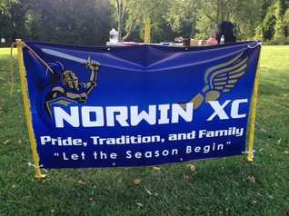
Where: Norwin’s campus grounds (parent pick-up from Hillcrest)
Who: Any student with an interest in running Middle School Cross Country during the Fall of 2022 (must be a 7th or 8th grader for the coming school year).
Why: Norwin Cross Country Coaches have created this camp for the following purposes:
- Giving students an opportunity to learn about the sport of cross country
- Allowing athletes to meet some of their future teammates and coaches.
- Enabling parents to receive information and ask questions about summer XC opportunities.
To be completed in advance of camp: Students should sign up for our Google Classroom page (Code: 2tjvufg).
The parent permission form found at https://www.norwinxc.com/middle-school-info.html must be completed.
You may also go to norwinxc.com and then click on the “Middle School Info” tab to find the permission slip.
COVID/sickness protocol: Please do not attend school or our camp if you feel sick. If you do test positive for COVID after exposure to others at camp, please contact Coach Nanassy at nnanassy@norwinsd.org.
Participation in fall cross country is not required for students who choose to take part in this preview camp. We coaches hope that this camp gives students more information to determine if they would like to commit to this sport or not. Cost for this camp is $0. Each of the camp days will follow this schedule:
3:00 – Change into weather appropriate athletic wear in the Hillcrest locker rooms, if needed.
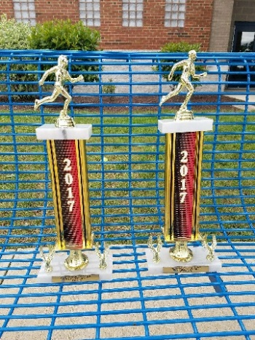
3:10 – Group meeting in the Hillcrest cafeteria or outside of Hillcrest
3:20 – Jog, stretching and warm-up exercises
3:30 – Cross country workout
3:50 – Activity (relay / group competition / game / other)
4:05 – Stretching and cool down exercises
4:15 – 4:30 – Parent pick-up at the front entrance of Hillcrest
If pick-up needs to occur earlier, have your child inform a coach; coaches will remain with students if parents are not able to pick up exactly at 4:30.
On the last day of camp (Wednesday, June 8th), a parent meeting will occur from 4:15 until approximately 4:30 in the Hillcrest cafeteria or potentially outside the front entrance of Hillcrest. This meeting will allow the Middle School cross country coaches to share materials and information with parents for the upcoming cross country season, as there are many optional summer activities that occur in preparation for the official beginning of cross country in August. A question and answer session will conclude this meeting.
If you cannot attend all days of the camp, please attend the days you can! If you need to arrive late / leave early, just inform a coach. Please be aware that you may need to ride the bus home if camp is cancelled due to weather issues.
The only items needed for camp are: workout clothes, running shoes, water bottle, & a completed parent form (online).
Questions: Contact Coach Nanassy at nnanassy@norwinsd.org or Call 724-861-3010 x04215

